Enterprise Network Topology and Architecture
Deepesh Oli

1. Network Overview
I designed and configured a enterprise network using Cisco Packet Tracer. To achieve this collapsed-core architecture, I use two multilayer switches, four access switches, two edge routers, and a simulated ISP network with ip 8.8.8.8
The main functionality is to provide reliable communication between different vlans department with redundant architecture and first hop redundancy protocol. Technologies such as VLANs, OSPF, HSRP, EtherChannel, STP, ACLs, DHCP, and NAT/PAT are implemented to support these requirements.
2. Network Architecture
2.1 Access Layer
The access tier has four Cisco Catalyst 2960 Layer 2 switches. They link PCs, wireless access points, and servers to the LAN. The LAN is split into four VLANs for different department group. Each VLAN runs with its own subnet. That helps stop broadcast traffic from mixing between departments. For redundancy, the access switches use trunk links toward both distribution switches. VLAN traffic can then move up to the distribution tier with backup paths.
2.2 Distribution and Core Layer
Two Cisco Catalyst 3650 multilayer switches make up the combined distribution and core area. They do inter VLAN routing using SVIs. They also provide links from the access switches to the edge routers. HSRP is set on both multilayer switches. One switch runs as the main gateway while the other is ready to take over. Different HSRP priorities are used so the gateway role is shared in a planned way. If a switch drops, the other keeps gateway duty. The multilayer switches also connect with EtherChannel using LACP. Multiple physical links join into one logical link. STP is enabled to reduce the risk of Layer 2 loops and to handle redundant paths. OSPF is used for dynamic routes between the distribution switches and the edge routers. ACLs are added to limit traffic flows between picked departments.

2.3 WAN Edge and Internet Connectivity
Two edge routers exist here: EDGE-1 and EDGE-2. Each one links to both distribution switches. This gives extra route options when traffic exits the internal side. The internal routed links use four /28 networks. The ISP side uses 203.0. 113.0/30 and 198.51. 100.0/30. Each edge router connects to a simulated ISP router. 8.8. 8.8 is used as the outside test target for reachability checks. NAT/PAT is enabled on the edge routers so internal hosts can reach the external network.

3. Network Redundancy and Security
Redundancy shows up throughout this design. HSRP gives backup default gateways. OSPF can use other routes if needed. EtherChannel adds more bandwidth and keeps paths available. STP is used to stop layer 2 switching loops when there are multiple connections. Security is added in a few places too. ACLs block unwanted traffic between VLANs. Port security restricts who can use the switch ports. SSH is set up for safe remote management. For addressing, VLAN 30 uses a single DHCP server. DHCP relay helps this server reach clients across the network. A DNS server is also present so devices can resolve names.
4. Network Traffic Flow
Inside one VLAN, devices talk using layer 2 forwarding, so switching handles the frames. When two devices are in different VLANs, the traffic goes to the virtual default gateway on the distribution layer. Inter-VLAN routing happens there. For Internet access, traffic moves from the access layer to the distribution switches. Then it goes to an edge router that can forward it to the ISP network. The extra links are meant to keep things working if a link goes down, or if a distribution switch or edge router is not available.

Subnetting
Subnet mask: 255.255.255.240 (/28)
Block size: 16 addresses per subnet (256 − 240 = 16)
Usable hosts per subnet: 14 (16 minus network and broadcast)
Number of subnets: 16
Subnet | Network Address | Usable Host Range | Broadcast Address
1 | 192.168.10.0 | 192.168.10.1 – 192.168.10.14 | 192.168.10.15
2 | 192.168.10.16 | 192.168.10.17 – 192.168.10.30 | 192.168.10.31
3 | 192.168.10.32 | 192.168.10.33 – 192.168.10.46 | 192.168.10.47
4 | 192.168.10.48 | 192.168.10.49 – 192.168.10.62 | 192.168.10.63
5 | 192.168.10.64 | 192.168.10.65 – 192.168.10.78 | 192.168.10.79
6 | 192.168.10.80 | 192.168.10.81 – 192.168.10.94 | 192.168.10.95
7 | 192.168.10.96 | 192.168.10.97 – 192.168.10.110 | 192.168.10.111
8 | 192.168.10.112 | 192.168.10.113 – 192.168.10.126 | 192.168.10.127
9 | 192.168.10.128 | 192.168.10.129 – 192.168.10.142 | 192.168.10.143
10 | 192.168.10.144 | 192.168.10.145 – 192.168.10.158 | 192.168.10.159
11 | 192.168.10.160 | 192.168.10.161 – 192.168.10.174 | 192.168.10.175
12 | 192.168.10.176 | 192.168.10.177 – 192.168.10.190 | 192.168.10.191
13 | 192.168.10.192 | 192.168.10.193 – 192.168.10.206 | 192.168.10.207
14 | 192.168.10.208 | 192.168.10.209 – 192.168.10.222 | 192.168.10.223
15 | 192.168.10.224 | 192.168.10.225 – 192.168.10.238 | 192.168.10.239
16 | 192.168.10.240 | 192.168.10.241 – 192.168.10.254 | 192.168.10.255

Testing and troubleshooting cases
Case 1:
Failure of one edge router (Test of redundancy on my network)
I setup two edge router connected to the Internet(8.8.8.8), so that incase of failure or outage by whatever reason can be, the other edge router should take place instantly and network should continue to be operation.
Scanerio: edge router 1 is down
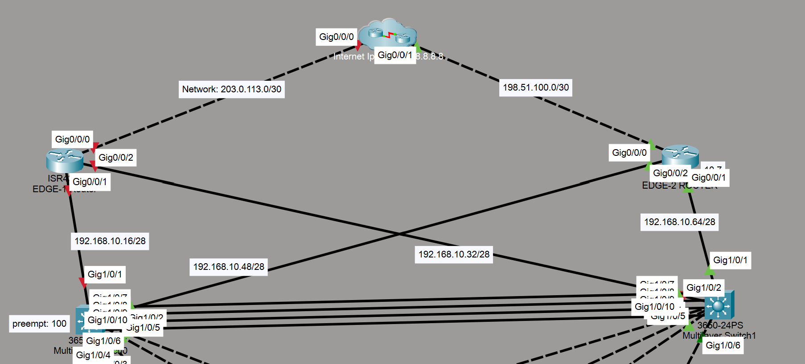

Test: Ping to edge router is unreachable however ping to Internet 8.8.8.8 is successful.
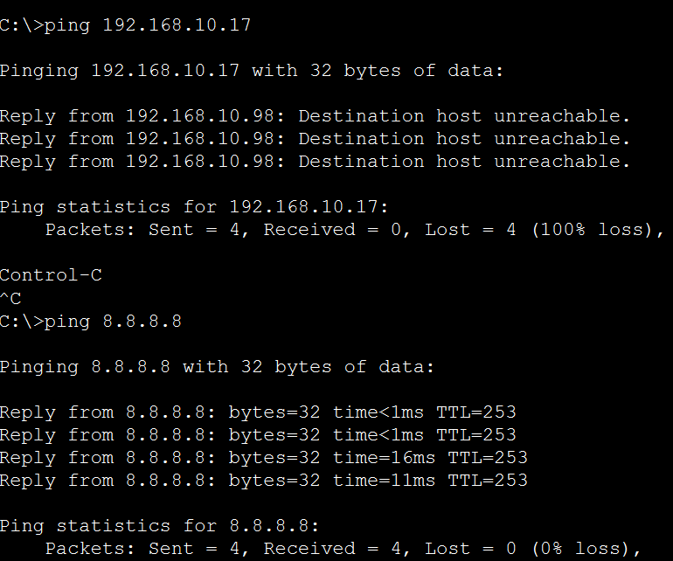

Result: The network remains operations even though there is catastrophic failure in edge router 1 indicating that there is redundancy and first hop redundancy protocol in place.

Case 2:
Problem: One of two multilayer switch of this network is down
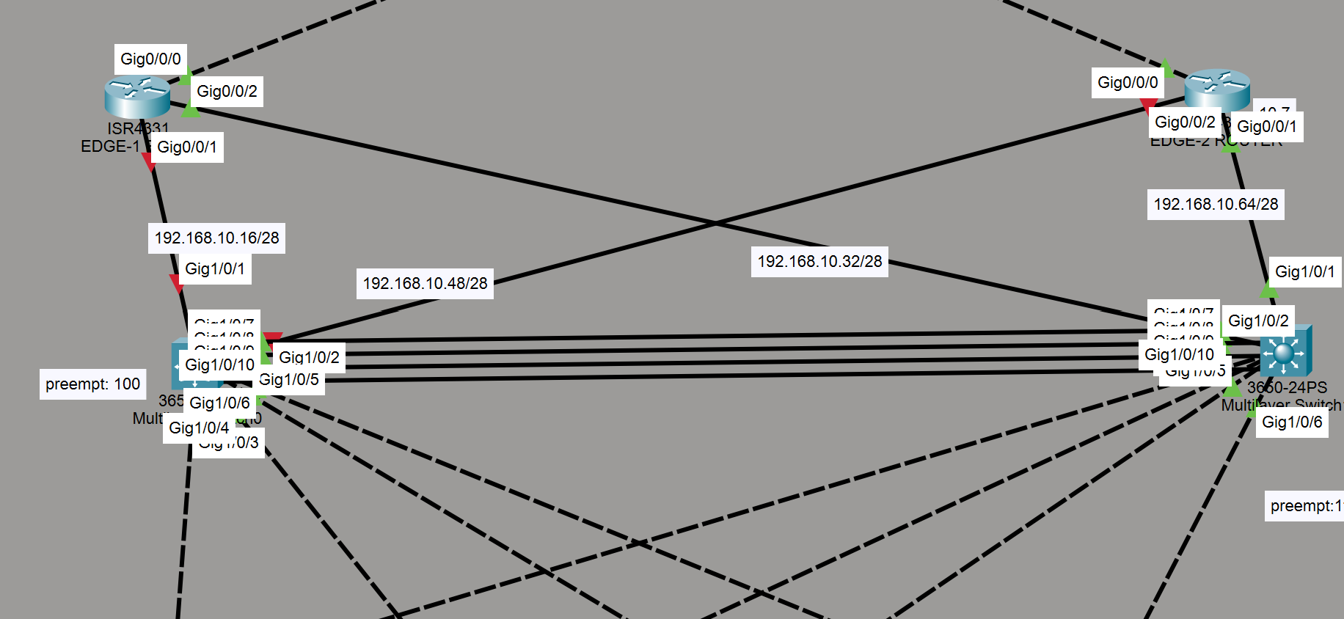

Test: Ping to multilayer switch one is unsuccessful however the pcs on all vlans could still connect to the internet.
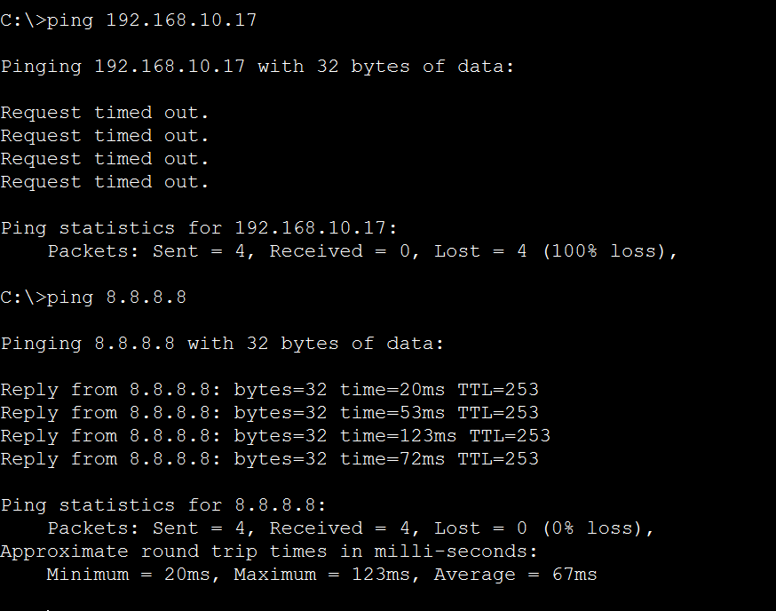d

Result: When multilayer switch one is down, the network switched to multilayer switch 2 which had higher preempt value of 110, which shows that the first hop redundancy, Hot standby router protocol (HSRP) is working and network is redundant.

Troubleshooting #1: DHCP Failure Caused by ACL
Problem:
A PC in Finance VLAN 20 was unable to obtain an IP address automatically from the DHCP server. Packet Tracer displayed:
DHCP failed. APIPA is being used.
The PC received a 169.254.x.x APIPA address instead of an address from the Finance subnet (192.168.10.96/28).
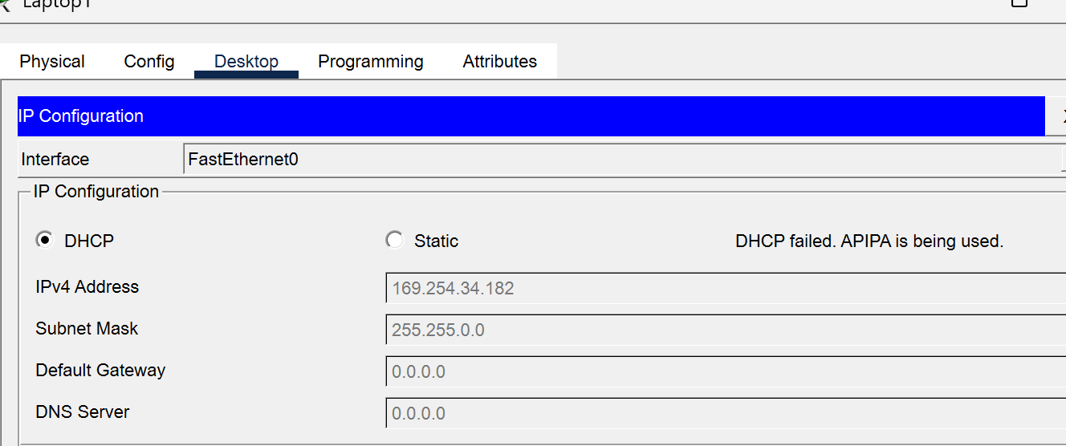

Troubleshooting Process:
First, connectivity between the Layer 3 switch and the DHCP server (192.168.10.117) was tested:
ping 192.168.10.117
The ping was successful, confirming that the DHCP server was reachable. The ip helper-address on VLAN 20 was also verified:
interface vlan 20
ip helper-address 192.168.10.117
DHCP was then tested on another VLAN, and it worked successfully. This indicated that the DHCP server and DHCP relay configuration were functioning correctly.
The main difference was that VLAN 20 had an inbound ACL applied. The ACL was temporarily removed:
interface vlan 20
no ip access-group FINANCE_ACL in
After removing the ACL, the Finance PC successfully obtained an IP address from the DHCP server.
Root Cause:
The inbound ACL on VLAN 20 was blocking the initial DHCP request. A new DHCP client does not yet have an IP address, so its initial DHCP Discover did not match the ACL rule that permitted traffic specifically from the Finance subnet.
Solution:
The ACL was temporarily removed from VLAN 20, allowing DHCP traffic to reach the DHCP relay and DHCP server successfully.
Permanent solution:
Providing dhcp permit before acl rules apply
ip access-list extended FINANCE_ACL
permit udp any eq bootpc any eq bootps
deny ip 192.168.10.96 0.0.0.15 192.168.10.128 0.0.0.15
permit ip 192.168.10.96 0.0.0.15 any
Result:
The Finance PC successfully received a valid IP configuration from the DHCP server
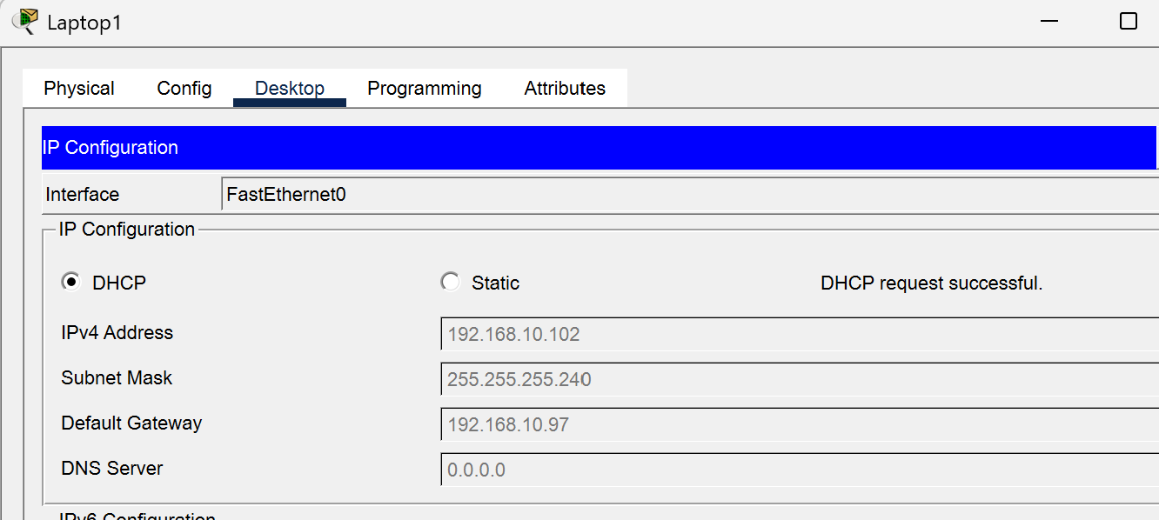

Configuration commands and details

enable
configure terminal

ip routing

Create VLANs
vlan 10
name VLAN10
exit

vlan 20
name VLAN20
exit

vlan 30
name VLAN30
exit

Ports going DOWN to the 2960 access switches
interface range gigabitEthernet1/0/3 - 5
switchport mode trunk
switchport trunk allowed vlan 10,20,30
no shutdown
exit

VLAN 10
interface vlan 10
ip address 192.168.10.82 255.255.255.240
standby 10 ip 192.168.10.81
standby 10 priority 110
standby 10 preempt
no shutdown
exit

VLAN 20
interface vlan 20
ip address 192.168.10.98 255.255.255.240
standby 20 ip 192.168.10.97
standby 20 priority 110
standby 20 preempt
no shutdown
exit

VLAN 30
interface vlan 30
ip address 192.168.10.114 255.255.255.240
standby 30 ip 192.168.10.113
standby 30 priority 110
standby 30 preempt
no shutdown
exit

Make MLS1 preferred STP root
spanning-tree vlan 10,20,30 root primary

end
write memory

configuration for switch1

enable
configure terminal

ip routing

vlan 10
name VLAN10
exit

vlan 20
name VLAN20
exit

vlan 30
name VLAN30
exit

Ports going DOWN to 2960 access switches
interface range gigabitEthernet1/0/3 - 5
switchport mode trunk
switchport trunk allowed vlan 10,20,30
no shutdown
exit

VLAN 10
interface vlan 10
ip address 192.168.10.83 255.255.255.240
standby 10 ip 192.168.10.81
standby 10 priority 100
standby 10 preempt
no shutdown
exit

VLAN 20
interface vlan 2
ip address 192.168.10.99 255.255.255.240
standby 20 ip 192.168.10.97
standby 20 priority 100
standby 20 preempt
no shutdown
exit

VLAN 30
interface vlan 30
ip address 192.168.10.115 255.255.255.240
standby 30 ip 192.168.10.113
standby 30 priority 100
standby 30 preempt
no shutdown
exit

Backup STP root
spanning-tree vlan 10,20,30 root secondary

end
write memory

hsrp is setup between l3 switches with vlan 10 ip on one switch and same subnet vlan 10 ip in another l3 switch, and then setting up same ip for standby ip address (virtual ip gateway with preempt of course)

FOR PER VLAN LOAD BALACING USING SVI
HSRP
interface vlan 10
standby 10 priority 110
standby 10 preempt

interface vlan 20
standby 20 priority 110
standby 20 preempt

interface vlan 30
standby 30 priority 100
standby 30 preempt

interface vlan 40
standby 40 priority 100
standby 40 preempt

STP
spanning-tree vlan 10,20 root primary
spanning-tree vlan 30,40 root secondary

SVI, INTERVLAN ROUTING, VLSM SETUP: COMPLETE

HSRP Setup Complete.

- First I have setup backup router with virtual ip address i.e 192.168.10.1, the main router has standby priority of 110 and backup router has standby priority of 100
- I have set up another hsrp on two multilayer switches. Here, per vlan load balancing preempt 110 on second l3 switch for vlan 40, it is primary root(Stp) and for other vlans, the first l3 is the primary root, these l3 switches have hsrp configured for each vlan. So vlan 40 has second l3 has primary switch and other vlans has first switch as primary switch, so by doing that, we achieved load balancing.

VLAN Setup Complete

Static Routing: default route to isp 1, via its own interface g0/0/1

ROUTING PROTOCOL: OSPF, passive-interface, default-information originate all complete

Security:
Port security: Mac address: Sticky
Violation: Shutdown
Maximum: 1

Device Security
Setting up secret passkey

Service password-encryption
enable secret deepesh
Line console 0
Password deepesh
Login

ACLs:
First case: There is Intervlan routing from vlan 20(finance) to vlan 40 (Account)
Source IP: 192.168.10.101
Destination IP: 192.168.10.135

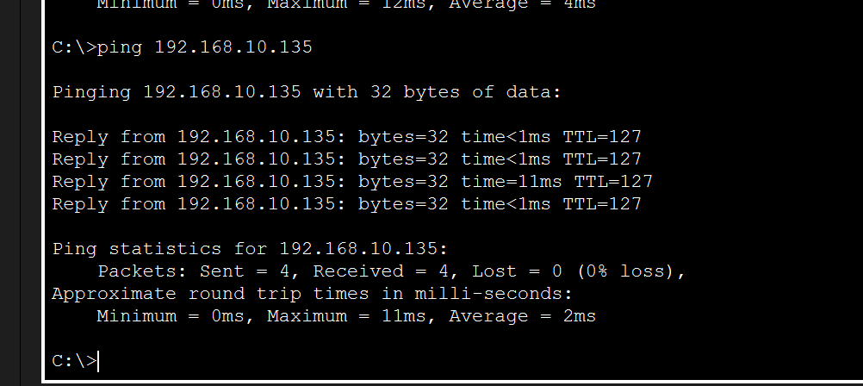

After:
Blocking connection from finance to accounting
ip access-list extended FINANCE_ACL
deny ip 192.168.10.96 0.0.0.15 192.168.10.128 0.0.0.15
permit ip 192.168.10.96 0.0.0.15 any
exit

interface vlan 20
ip access-group FINANCE_ACL in

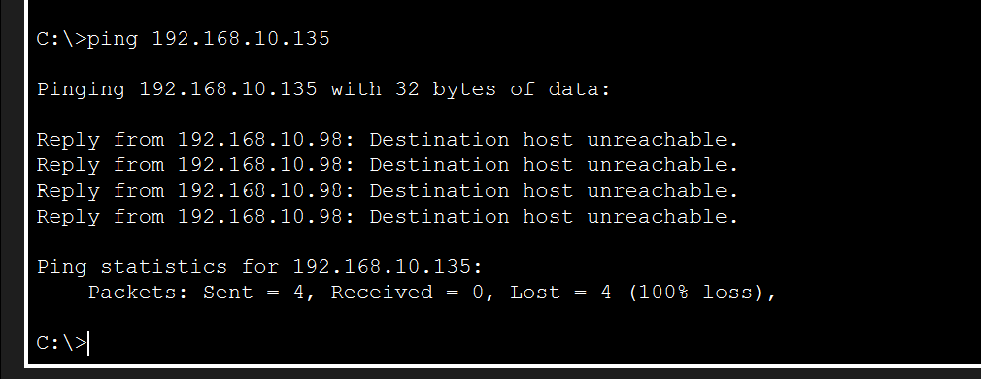

Vlan 20 (Science) to vlan 40(Account) shows as Destination host unreachable.

Setting up the dhcp server
I setup dhcp server on vlan 40, created pool for each vlans and then in both multilayer switches carrying all trunks vlans,
int vlan 10
ip helper-address 192.168.10.117

int vlan 20
ip helper-address 192.168.10.117

int vlan 40
ip helper-address 192.168.10.117

Etherchannel setup
Etherchannel is setup using LACP protocol, and 4 interfaces are used i.e g1/0/7-g1/0/10
Channel-group 20 mode active

Remote Control: Setting up ssh
en
conf t
hostname
ip domain-name deepesh.com
username deepesh secret deepesh
ip ssh version 2
crypto key generate rsa
2048

line console 0
logging synchronous

line vty 0 15
login local
transport input ssh

hostname: internet, edgerouter1, edgerouter2, multilayer1, multilayer2
domainname: deepesh.com

NAT/PAT TRANSLATION
So on EDGE-1, G0/0/0 is outside, while G0/0/1 and G0/0/2 are inside. Configure:
conf t

access-list 1 permit 192.168.0.0 0.0.255.255

interface g0/0/0
ip nat outside
exit

interface g0/0/1
ip nat inside
exit

interface g0/0/2
ip nat inside
exit

ip nat inside source list 1 interface g0/0/0 overload

end
For EDGE-2, it's the same arrangement:
conf t

access-list 1 permit 192.168.0.0 0.0.255.255

interface g0/0/0
ip nat outside
exit

interface g0/0/1
ip nat inside
exit

interface g0/0/2
ip nat inside
exit

ip nat inside source list 1 interface g0/0/0 overload

end
show ip nat translations
show ip nat statistics

NAT/PAT TRANSLATIONS RESULT
Command used: show ip nat translations
Show ip nat statistics



